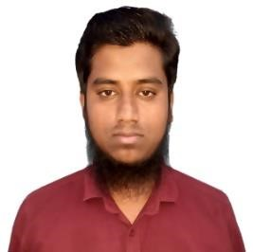

**Md.Obaydullah**

Flat 7 (North), Road no-04, Mirpur -06, Dhaka-1216

Email:obaydullah599@gmail.com

# Career Objective

To build up a long term career in software development in such an organization where there will be opportunities for further development and growth, where I could be able to use my skills in the best possible way to achieve the company’s goals

# Education

* **BA (BSC Hon’s) in Computer Science & Engineering**

University of Ideal Institute of business and science

Passing Year : Running

Result : …

Running Year : final year

* **Higher Secondary Certificate (HSC)**

|  |  |  |
| --- | --- | --- |
| Concentration | : | Science |
| Board & Year | : | Dhaka,2016 |
| GPA | : | 3.83 of5.00 |

* **Secondary School Certificate (SSC)**

|  |  |  |
| --- | --- | --- |
| Concentration | : | Science |
| Board & Year | : | Comilla, 2016 |
| GPA | : | 4.50 out of5.00 |

# Technical Skill

* Two projects Created
* Ecommerce Project Develop by Web Form application in c# programming language
* Learning Management System project develop by Asp.net MVC Framework
* HTML5, CSS3, Bootstrap, Solid Principle, Design Pattern (Singleton, Repository, Creational)
* ASP.net MVC Framework in C#
* Object Oriented Programming
* Software Development Life Cycle
* Completed Top Up IT Training from ICT DIVISION of Bangladesh

# Personal Skill

* Creative and analytical project planning
* Hardworking and determined in achieving goal
* Team work activity
* HTML5, CSS3, Bootstrap, Solid Principle, Design Pattern (Singleton, Repository, Creational)
* ASP.net MVC Framework in C#
* Object Oriented Programming

**Achievement**

Award of medal by Premier League Cricket

Competitive Programming Contest

# Professional Experience

* Software developing
* Training &
* Motivating

**Reference**

|  |  |
| --- | --- |
| * Abdur Rashid   Pricipal of Tejgoan College  Phone: 01819 241355  Email: [abdurrashid@gmail.com](mailto:abdurrashid@gmail.com) | * Fakrul Alam, PhD   Pro-Vice Chancellor  East West University  Phone: 01556 343771  Email: [falam1951@yahoo.com](mailto:falam1951@yahoo.com) |